**Project Design Phase-II**

**Data Flow Diagram & User Stories**

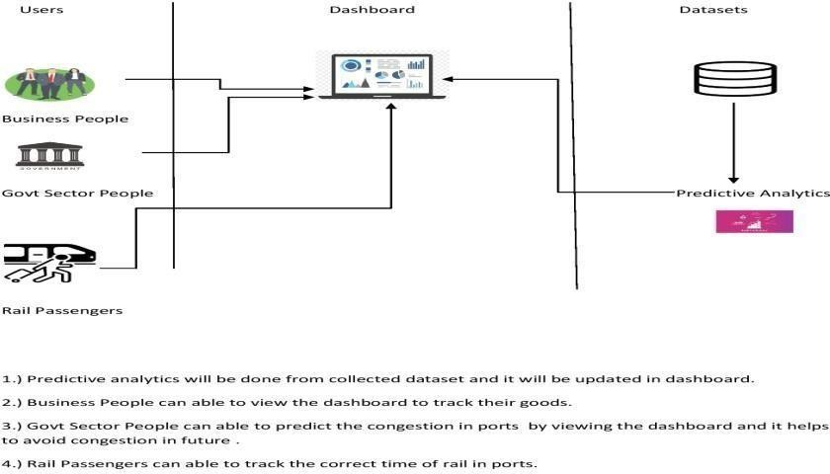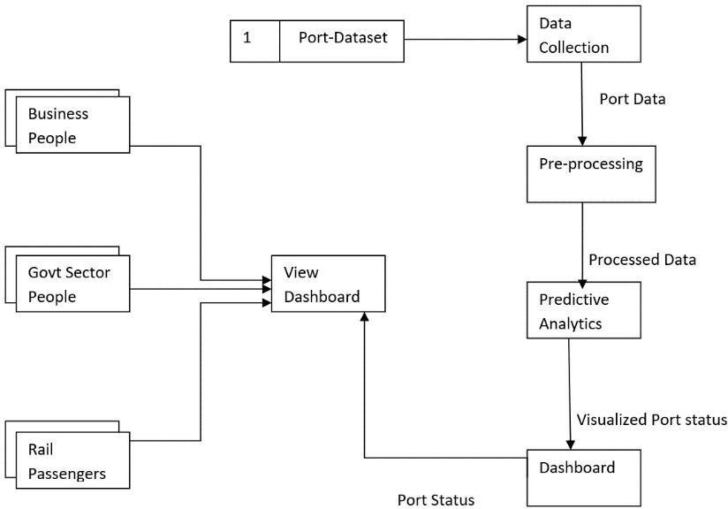

|  |  |
| --- | --- |
| Date | 18 October 2022 |
| Team ID | PNT2022TMID03743 |
| Project Name | Project – Traffic and Capacity Analytics for Major Ports. |
| Maximum Marks | 4 Marks |

**Data Flow Diagrams:**

A Data Flow Diagram (DFD) is a traditional visual representation of the information flows within a system. A neat and clear DFD can depict the right amount of the system requirement graphically. It shows how data enters and leaves the system, what changes the information, and where data is stored.

**DATA FLOW DIAGRAM**

**User Stories**

Use the below template to list all the user stories for the product.

|  |  |  |  |  |  |  |
| --- | --- | --- | --- | --- | --- | --- |
| **User Type** | **Functional**  **Requirement (Epic)** | **User Story**  **Number** | **User Story / Task** | **Acceptance criteria** | **Priority** | **Release** |
| Business People | Monitoring | USN-1 | As a user, I can view the dashboard to see the port status . | I can visualize the port status in dashboard. | High | Sprint-1 |
|  | Tracking | USN-2 | As a user,I can track the goods. | I can track the goods by it’s arrival/departure time | High | Sprint-1 |
| Government Sector People | Viewing | USN-1 | As a user,I can view the port status regularly | I can able to know the port status | Low | Sprint-2 |
|  | Predicting | USN-2 | As a user,I will reduce the congestion in ports by predicting the port congestion through dashboard. | I can able to predict the congestion in future | High | Sprint-2 |
| Passengers | Tracing | USN-1 | As a user, I can trace the arrival/departure time of rail in ports. | I can able to track the correct time of rail. | High | Sprint-2 |